ArteVida Fundraiser ~ Creating PEACE through Art
Posted by kathy in Community, Events, Featured
Art, music, food and style collided last Saturday night at the ArteVida Fundraiser for PEACE attracting a fashionable cross-section of locals from Puerto Vallarta to Punta Mita (with a few “Chilangos” mixed in for flavor), international and Mexican artists from throughout the republic, sponsors and philanthropists.
PEACE was not kidding when they said this event would take place in a stunning home. Casa Las Gaviotas a private residence inside El Farallon is absolutely spectacular and a great space for an event especially one that started at sunset.
Artists donated their beautiful works and Mexico Boutique Hotels contributed vacations at their properties for this fund raising event with both live and silent auctions. The star piece of the evening was created by the PEACE women under the direction of Ana Pena Mejia who created a framed mirror out of recycled bottle caps (in true PEACE spirit) that sold for over double it´s estimated price to many cheers in the live auction.
Catered by NAEF Cuisine from Punta de Mita with delectable food, delicious wine (that made for a long curvy trip back to Punta Mita!) and music by Los Frixoleros made for an enjoyable evening.
We would like to give a special nod to Sayulita artist Evelyn Boren who not only attended the event and donated a wonderful piece of her artwork but also worked quite hard and humorously in inspiring everyone to be generous with his or her bids in the live auction.
We also bid a fond farewell to Katherine Fisher from PEACE who spent her last night in Mexico working hard to insure the events success and has now gone to teach yoga in Indiana. Katherine you will be missed!
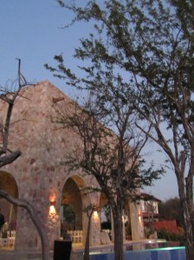
Casa las Gaviotas
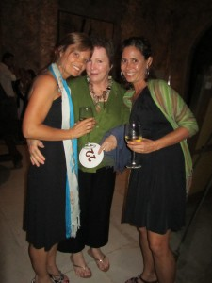
Katherine and Molly Fisher
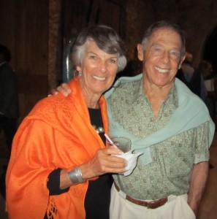
Howard & Lennie Weiser
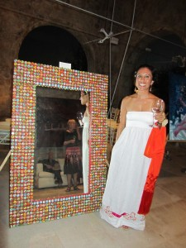
Ana Pena Mejia / El Espejo
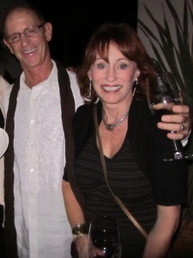
Rick and Sally Smith
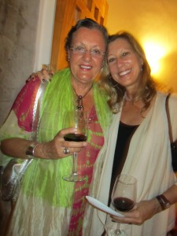
Artist Evelyn Boren and Lynne Bairstow
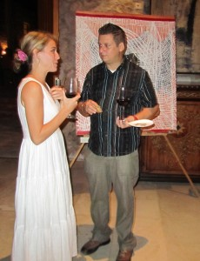
Art, food and wine!
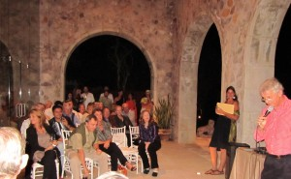
The Live Auction
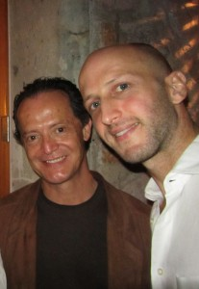
Artist and Pierre from Naef Cuisine

