Disadvantaged Youth on PEACE Field Trip of a Lifetime
Written by Peace Mexico on 31 Mar 2011
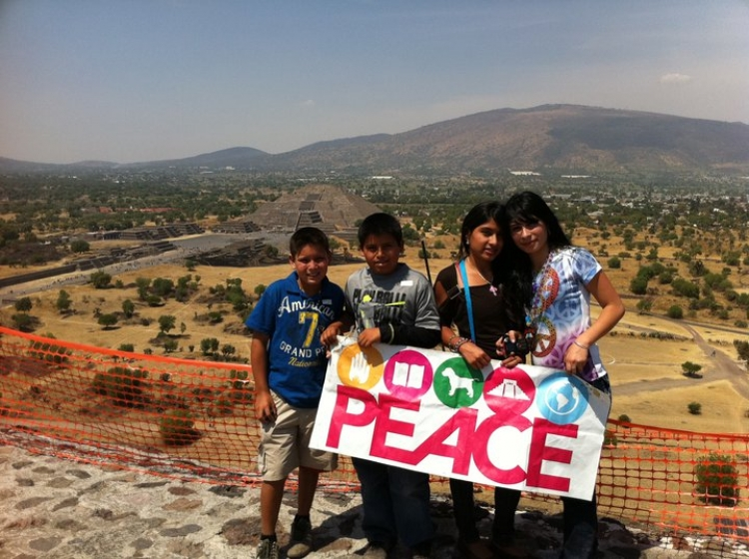
After washing cars, picking up trash and selling calendars to raise money, frequent nightmares of plane rides, and months of excited anticipation, four alternative school students at local non- profit, PEACE experienced a field trip of a lifetime: to Mexico
Often referred by locals as “El Monstruo,” or “The Monster,” because of its sheer size and depth of its ancient roots and culture, Mexico City might has well be Mars for youth who had hardly stepped outside of their home town, Punta de Mita, a small fisherman’s village of 2,000
“We saw the ancient historic center Zócalo and the Teotihuaca pyramids,” said Rosa Alicia Aguilar Elias, Teacher at the alternative school, and chaperone of the field trip . “They were like sponges, absorbing all of the foreign sights and smells around them. The trip broadened their entire world view and perspective.
The alternative school was launched in March, 2008 by PEACE, to serve disadvantaged youth not enrolled in the public school system due to lack of funds and parental interest, missing birth certificates and/or behavioral
“Most of the students in the alternative school come from extremely difficult home lives, and yet they show up for school every day,” said Nikhol Esteras Roberts, Co-Director of PEACE’s education program. “They take initiative in their education, they are hungry to learn, and they have tremendous strength; I admire them for that.
Fifteen students, from ages eight to seventeen attend the school from Monday through Friday and work towards their elementary or middle school certificates. The school believes in using innovative, hands-on techniques to promote project-based learning and also employs a psychologist who works with students, parents and teachers to promote the healthy emotional and academic development of
“This trip was such an impactful way to deliver our hands on approach,” Elias said. “These are the types of experiences that shake ignorance, grow character and provide learning experiences that I could ever teach them from a book.
With so many new experiences under their belts, these students can view the world as one full of
“I saw Punta de Mita from the sky,” said Juan de Jesus Garcia Delgado, an alternative school
Now, in Juan’s mind, the sky is the limit.
PEACE: Protection, Education, Animals, Culture and Environment, is a nonprofit organization established in 2005, made of three main programs which focus on education, entrepreneurship, animal well-being, and community engagement in the coastal regions of Nayarit, Jalisco and Quintana Roo, Mexico. Through innovative and community based programs, PEACE is working to improve the quality of life in local communities throughout the Bahía de Banderas. For more information, please visit www.PeaceMexico.org.
For more information contact:
Becci Burchett
PEACE Mexico
becci@peacemexico.org

