PEACE Accepting Summer Internship Applications
Written by Peace Mexico on 20 Mar 2011
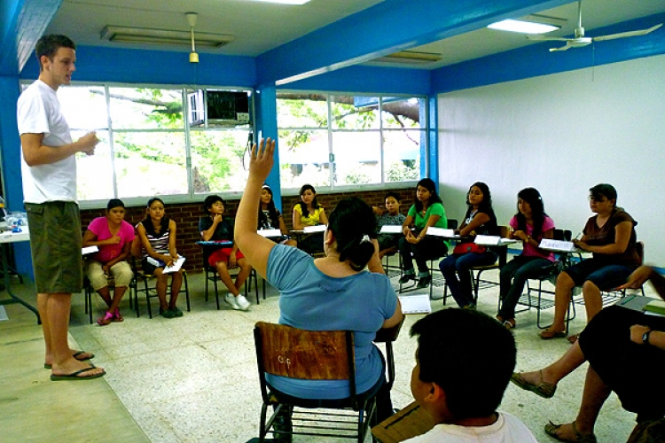
Local non-profit, PEACE, is creating its sixth annual summer camp experience for disadvantaged children and young adults throughout the Bay of Banderas this summer, and is accepting camp counselor internship applications from national and international students.
“PEACE interns learn experientially alongside staff members, gaining tremendously valuable work experience and bettering communities throughout the bay,” said Nikhol Esteras Roberts, Director of Casa Comunidad, PEACE’s education program.
College students or graduate interns work with local teachers and PEACE staff to teach local students during a 3-week summer camp with a curriculum focused on developing entrepreneurial skills. Each intern is responsible for shaping the educational experience for a class of 15 students in elementary or middle school. By the end of the camp, each class completes the process of creating an entrepreneurial venture. Skills taught include English, marketing, fundraising, accounting, computer skills and effective management practices.
"By interning in PEACE, I learned to work in an environment where I developed the capacity to be more self-empowered. I learned how to be more extroverted by interacting with people from the communities, learned about their necessities, and about their culture." Jorge Villanagra, PEACE Intern.
The 5-week internship program takes place in from July 9th 2011, to August 14th, 2011. Interns receive training during their first week, followed by three weeks of camp counseling. The fifth week is spent working on community projects such as making community gardens, painting houses, or building parks.
For more information or to apply, contact becci@peacemexico.org or visit http://www.peacemexico.org/intern.php
PEACE: Protection, Education, Animals, Culture and Environment, is a nonprofit organization established in 2005, made of four main programs which focus on education, entrepreneurship, animal well-being, and community engagement in the coastal regions of Nayarit, Jalisco and Quintana Roo, Mexico. Through innovative and community based programs, PEACE is working to improve the quality of life in local communities throughout the Bahía de Banderas. For more information, please visit www.PeaceMexico.org.

