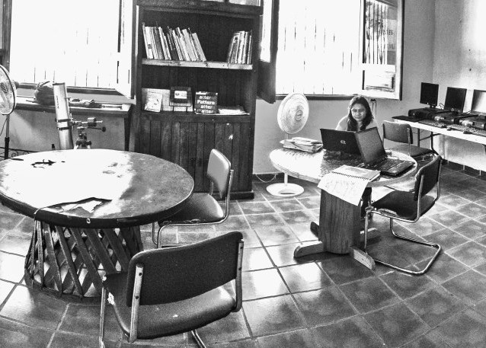

PEACE brings a new Library and Computer Center to Punta de Mita!
Posted by Tere in Community, Featured, News
We can’t express how much we love sharing PEACE’s news: this organization never ceases to amaze us, with their superb work and the invaluable benefits they bring to our community: painting schools, planting trees, organizing nutrition workshops, sponsoring free animal clinics, sport and cultural events, and …we could go on and on. The PEACE team never rests. And now, we’re excited to share the news of their two most recent projects.

Back in 2008, PEACE started a “collection” of books inside Casa Campesina. Little by little, that collection has increased and, this summer, volunteer Rosalinda Markels decided to create a special space to showcase these — a new community library! She painted the space, and organized all the books, so that finally the community has a place to enjoy the pleasure of reading.

It is sad to think that until few years ago, reading wasn’t integrated at all in the community’s habits. Now, thanks to the reading-writing workshops that PEACE organizes for kids and teenagers, this special place has really became useful.

Most of the readers are kids and high school students who have discovered the love and importance of reading. Many of them are growing up in disadvantaged households, some with family problems and other adverse conditions, which encourage PEACE to keep working harder and harder to create more opportunities for their social, economic and personal development. Many of these kids can’t read better than their own parents, who in many cases do not know how to read themselves.

Books are important, they take you to wonderful worlds and inspire the imagination, but technology is also very important in today’s world.

A year and half ago, Televisa donated 20 computers to the area, 10 of them went to the Higuera Blanca junior high-school and 10 were given to PEACE. Together with these, they received another donation of 5 more computers, but unfortunately only 4 of them worked.

A year ago, PEACE was able to install 4 computers, these have been working since then. But it was until few weeks ago that an “angel” visited Casa Campesina and realized that PEACE had 10 brand new computers ready to be used, but that hasn’t been installed because of lack of funds for the Internet connections and power regulators. This angel donated the amount necessary and a couple of days later, the 10 computers were up and running!

Today the PEACE computer center has 14 computers, all offering free Internet access for the entire community. Students go there to do their homework, and some adults go to do some research. It is important to say that PEACE has some pages restrictions to assure the equipment is being used for proper purposes.

Ceci, PEACE Director of Operations, tells us that they do the best they can with the resources they have, but it would be very helpful to receive donations to improve the facility. As well, books are always welcome, especially if they are in Spanish. If you don’t have any books and you would like to contribute, donations are received through PEACE´s website, and your contribution will help schedule more reading-writing workshops and hopefully start giving some computing lessons!

Isn’t it great what PEACE is doing for this community? We are very proud of PEACE, as a great role model to follow!
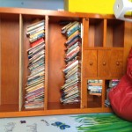
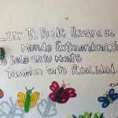
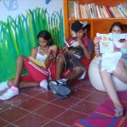

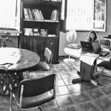
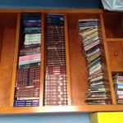
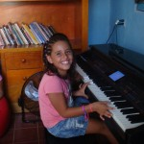
November 5, 2012
www.livepuntamita.com

