Home»News»News from Banderas Bay»Puerto Vallarta to Get Community Gardens
Monday, 17 January 2011 13:08

Puerto Vallarta to Get Community Gardens
Written by Keph Senett
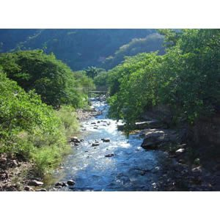Rio Cuale Rivera Cuale
Update: This project needs volunteers to come out on the morning of February 5 from 9:30am - 1pm for the groundbreaking.
Tools also needed - contact nicole@peacemexico.org.
Original post:
The Rivera Cuale condominium development is partnering with PEACE to create a riverside community garden on its grounds - the first of its kind in Puerto Vallarta.
The garden will serve as a hands-on educational space where students can learn about about indigenous plants and flowers, composting, nutrition and sustainable food production. Organizers hope that the gardens will inspire environmental awareness and community involvement in the youth of Puerto Vallarta.
The garden will be located just outside the condominium entrance plaza, and has already been designed. PEACE is looking for volunteers to help with the build. Interested parties should contact: nicole@peacemexico.org.
Past partnerships of Rivera Cuale and PEACE include an on-site fundraiser screening of the powerful documentary, "Home", a student clean-up day on the nearby Rio Cuale, and an on-site Cheko Carrillo fundraiser concert in November. Rivera Cuale is on record for being eco-friendly and community-engaged, and PEACE is grateful for its support and contributions to Puerto Vallarta.

