Home»News»News from Banderas Bay»Rivera Cuale-PEACE Community Gardens Offer Learning Opportunities for Local Youth
Wednesday, 30 March 2011 14:24

Rivera Cuale-PEACE Community Gardens Offer Learning Opportunities for Local Youth
Written by Keph Senett
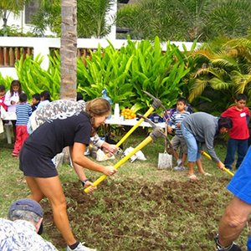
Rivera Cuale-PEACE Community Gardens PEACE Mexico
Thanks to local and foreign volunteers, the Rivera Cuale-PEACE community gardens are planted and thriving, offering educational opportunities to local youth.
The gardens, which were announced back in mid-January and planted in early February, are located on the Rivera Cuale condominium grounds, and offer a living site for hands-on workshops for both public and private schools wanting to incorporate ecology into their curricula. Local youth have been taking adavntage of the space to learn about indigenous plants and flowers, composting, nutrition and sustainable food production.
Locals aren't the only ones using the gardens. According to a recent press release issued by PEACE, on March 27th the first Vallarta Adventures "voluntour" group was hosted by the gardens, in a joint initiative with the Puerto Vallarta Garden Club where passengers from a cruise ship participated in weeding, composting, teaching children about planting seedlings, and building a trellis bed.
“We’ve seen overwhelming support from the local and foreign community as well as local businesses,” said Nicole Majewski, Community Relations Director at PEACE. “Everyone is so passionate about teaching youth about the environment and organic food. Although it is on private property, it truly is a community garden, with all demographics from this diverse city represented and contributing to its success.”
For more information or to donate supplies, contact Nicole@peacemexico.org.
PEACE (Protection, Education, Animals, Culture and Environment) is a nonprofit organization established in 2005, made of three main programs which focus on education, entrepreneurship, animal well-being, and community engagement in the coastal regions of Nayarit, Jalisco and Quintana Roo, Mexico. Through innovative and community based programs, PEACE is working to improve the quality of life in local communities throughout the Bahía de Banderas. For more information, please visit www.peacemexico.org.

